Introducing Signals
In this exercise, you will
- Appreciate what signals are and why Angular introduced them
- Learn difference types of signals
- Understand what a writable signal is
- Know how to use signals for local component state
- Integrate signals naturally with templates

What are signals in Angular?
- Signals are the foundation of state management in Modern Angular
- They make states explicit and predictable
- Designed for local, synchronous UI state
- a value that can tell Angular when it changes
Why do Signals exist?
- Change detection relied heavily on Zone.js
- Zone.js ties heavily on synchronous browser API such as promises, timers, DOM events, HTTP requests
- Angular often had to guess when state changed. The change detection is too harmful for highly responsive demands
- Signals remove that guesswork

What about RxJS?
- RxJS is still essential for async streams
- Signals complement RxJS for local state
- Zone.js is being phased out in favor of explicit reactivity
- RxJS is still the right tool for streams of events, web sockets, and complex asynchronous workflows
- Signals are the perfect use case when dealing with local synchronous UI state
Signal Types
- Writable signals: state you can change directly
- Computed signals: derived state based on other signals
- Effects: logic that reacts to signal changes
This exercise will focus only on the writable signals (The other two will be covered in next two exercises)

Exercise Steps:
- Create a new application with name Ex05 in Angular folder using same settings as Ex04.
- Open the application in VS Code
- Add new component counter
- In src/app.ts, import the counter component
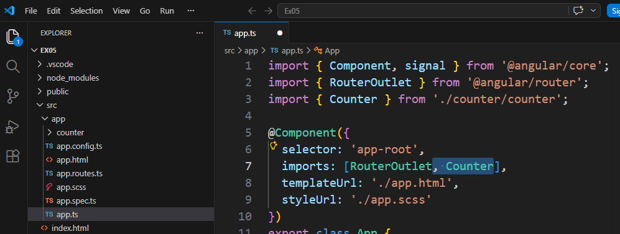
- In src/app.html
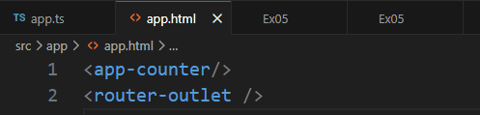
- Save all files, and run the application from terminal
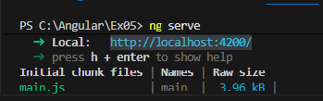
Display in browser page
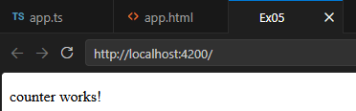

- In src/app/counter/counter.ts
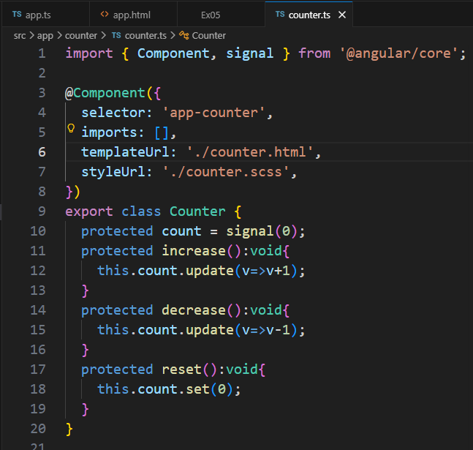
- In src/app/counter/counter.html
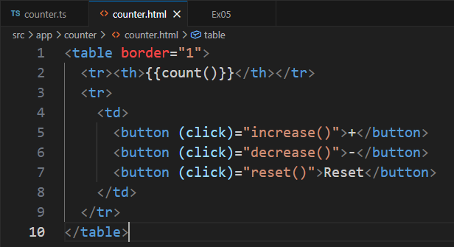
- Save all files and go to browser page
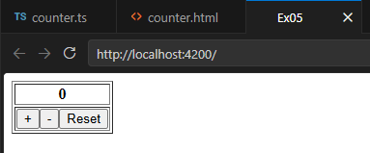
Try click all these buttons to observe the changes
- Close VS Code

